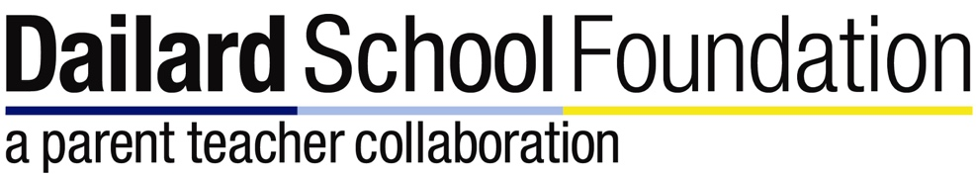

Hello Dailard Families,

Preparations are already underway for Dailardfest 2016! In order to make this another successful event, we need your help in securing fabulous auction items.

**How Can You Help?**

Think about who you know - Many companies in San Diego are very generous and love donating to worthy causes, but they have to be asked! Do you have a contact at a local hotel or venue? Do you have or know someone who has a vacation home or timeshare? What about extra airline miles?

Where do you go?- Salons, yoga/pilates studios, golf courses, etc. are great resources for donations. These companies are looking to advertise!

Do you have something to offer? Do you own a business or know someone who does? We’d love to have you help us get a foot in the door!

Have unique ideas? Have an awesome job or hobby that you could provide a fun “experience” such as rowing, surfing, climbing, crafting or beer brewing? How about professional or consulting services?

Help us!- Volunteer to help with donation acquisition! Many hands make light work.

Please take a minute to fill out [this questionnaire](https://docs.google.com/forms/d/1hhKCmaXo8FIK6sXRlz9ccBXPYM6157j0XT3KqFNlBqE/viewform) and let us know how you can help. We greatly appreciate your support in making Dailardfest 2016 a huge success!

The Dailard School Foundation